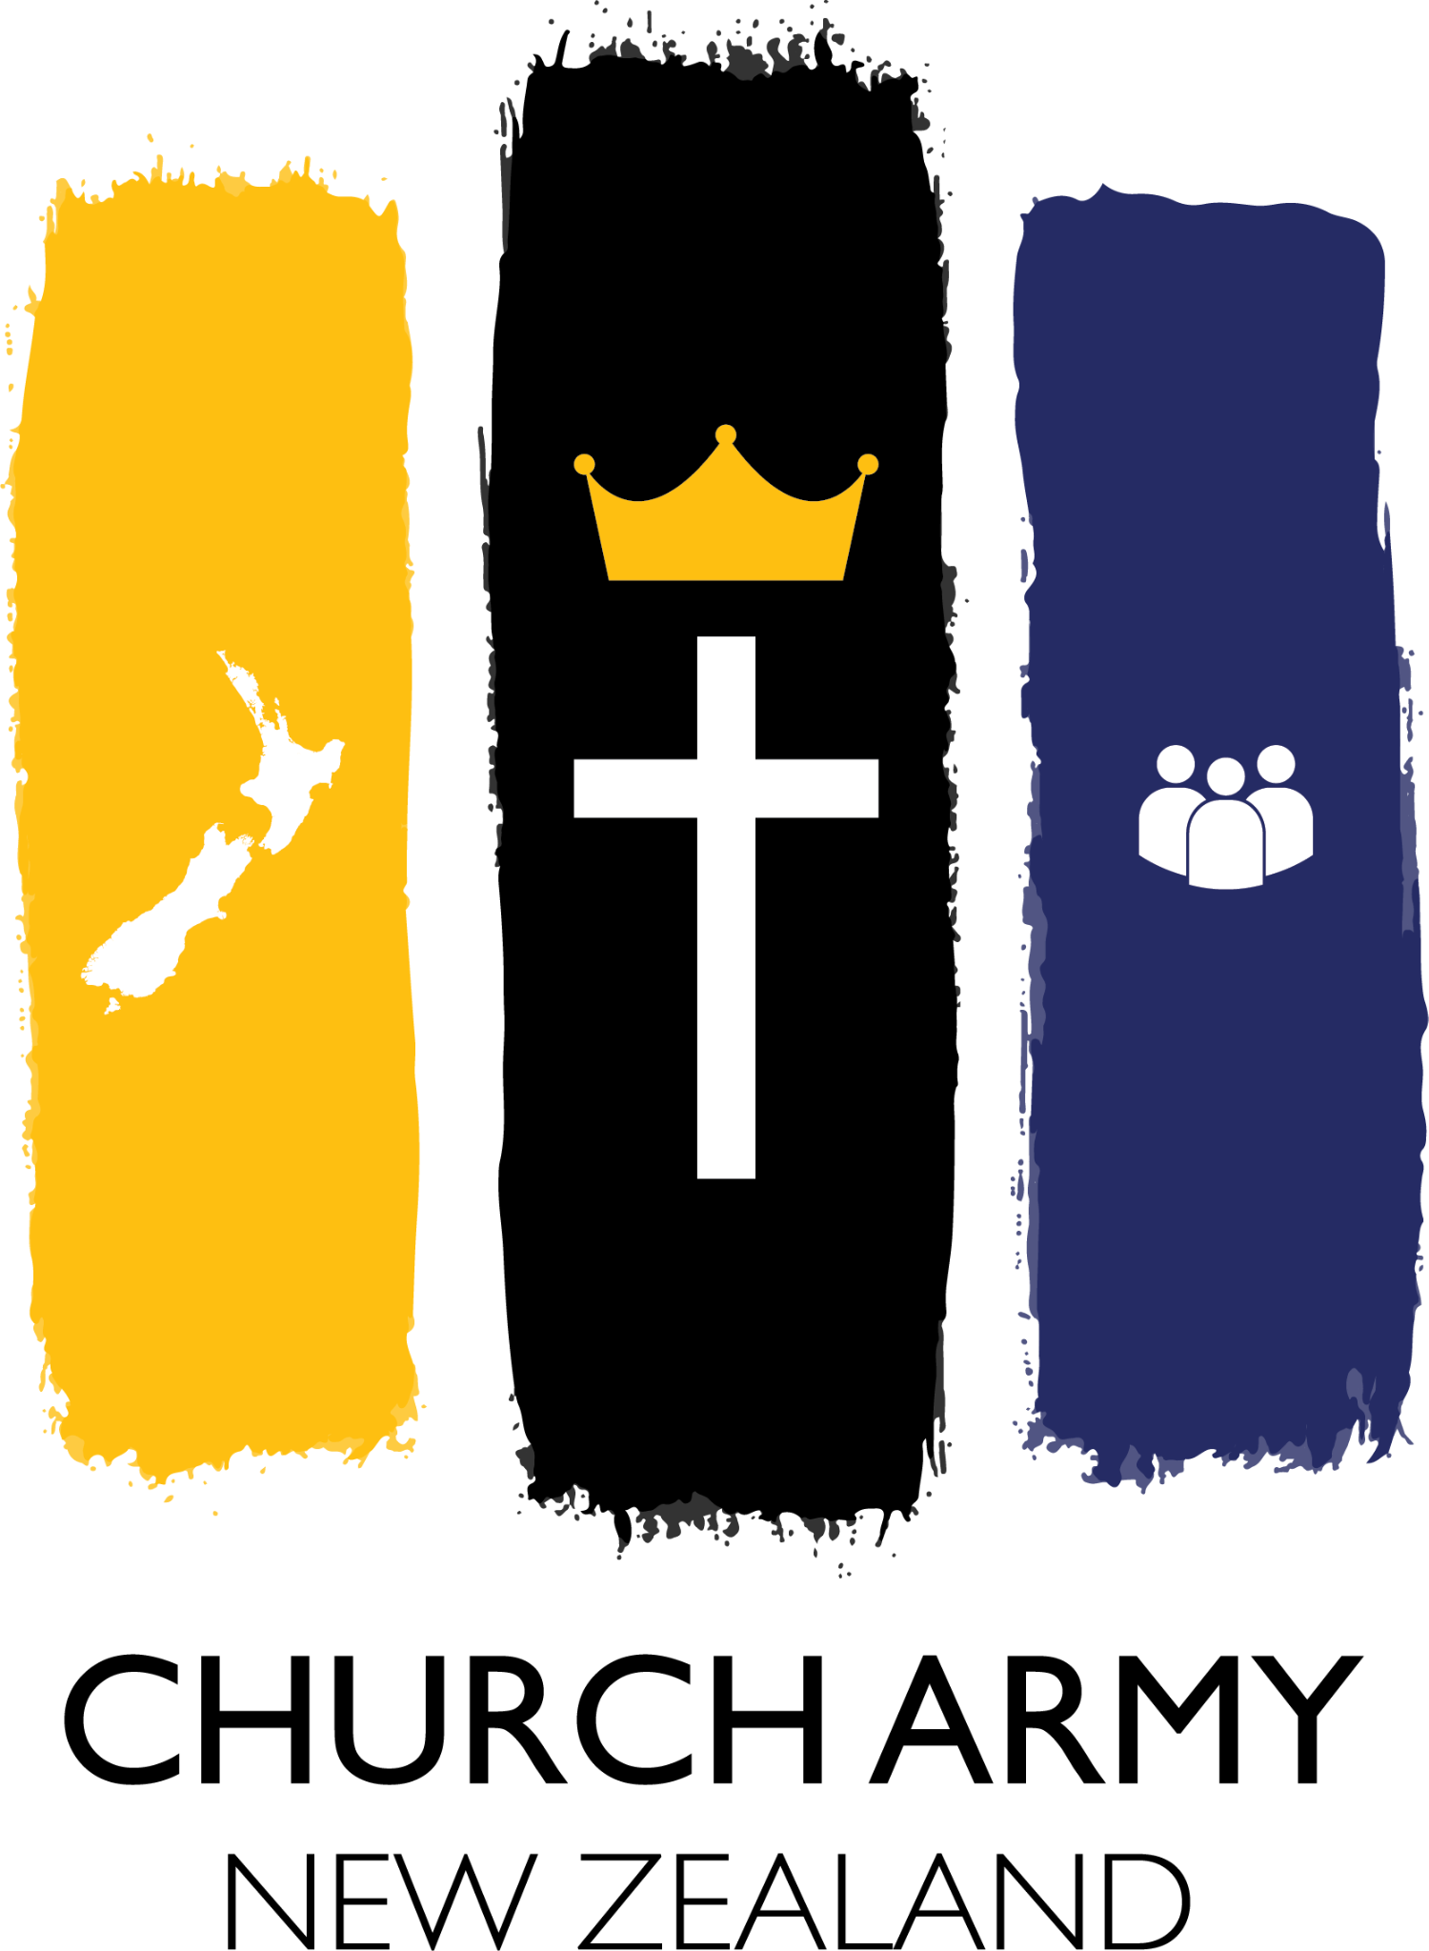Church Army NZ Report to General Synod/Te Hinota Whanui 2022

The Only Constant in Life Is Change.”- Heraclitus
One constant since the beginning of time might be change, however, the fear of change is also a constant. Since times immemorial, humans have liked routine. It makes us feel in control of our lives. …
“When you are finished changing, you are finished”. - Benjamin Franklin

I am pleased to say that Church Army NZ is only too willing to embrace the inevitability of change and adapt to it, for the sake of the Gospel. And we have seen plenty of it in the last two years!
Covid in its ongoing impact on every part of the world, New Zealand, community, whanau, individuals, our health and wellbeing, safety and economy, strategies and communication, imposed a need for flexibility and out of the box thinking, adapting, changing ..
This meant we had to draw closer than ever to God! But every challenge provides opportunities! And for Church Army NZ there appeared a strong silver lining around the Covid cloud, as it forced everyone to take stock and wrestle with the deeper meaning and source of life and safety, to face uncomfortable questions. And the Churches up and down the country were keener than ever to avail themselves of our expertise in training their people in engaging in grappling with those questions and sharing their hope giving faith.

In order to accommodate the increasing requests for training, coaching and mentoring, we decided at the beginning of 2020 to employ Pastor Brian Bullen and his wife Stephanie as our new national trainer. It was an inspirational move, as God then blessed us with even more opportunities, across many denominations all over the country and beyond! When Covid started to restrict our movements, Ps Brain’s great digital expertise and ease in all things cyberspace came into bearing. His outstanding ability to disciple disciple-makers helped spread the load and grow capable co-trainers and evangelistic leadership in many churches.
Spring of 2021 Ps Brian and team run an extremely fruitful 8 week (!) training tour in North and South Island!
November ‘21 the National Director also had the privilege of being one of the online speakers at the Auckland Prayer Breakfast, online.
Also Church Army, as part of AFFIRM, provided one of the courses run through Bishopdale Theological College in partnership with BTC, SOMA and NZCMS. These 3 or 4 session courses were so successful that we will run a follow up programme this year.

Our local ministries up and down the country also adapted to the new normal: a lot of the work was forced into cyberspace, and they are now continuing with that work, as it is effective!
Canterbury Kids Coach (CKC) is doing online training with families as far away as China! The local Discovery Bible Study (DBS) groups at times had to move to online meetings.
If through women leadership development, Children’s ministry, working with the broken and neglected or developing catalysts and movement leaders, it’s all about equipping and empowering the next generation and expanding capacity to be obedient to God in growing His Kingdom. 2020 and 2021, as any other year. It’s just the format that changed. If anything, we were busier than ever, as people realised their need for hope and sustaining power from outside their own abilities. There was a surge of interest in faith related conversations. We need to be equipped and ready to engage!
For that purpose CANZ is working towards more and more collaboration with other evangelistic organisations, like OAC, YWAM, NZCMS, SOMA, Latimer, Hope Project, Christian Network NZ, etc, to work more efficiently and effectively.
As we now have Ps Brian covering the North Island, National Director Capt Monika Clark has moved her home and CANZ HQ to Christchurch, for greater impact on the South Island!
Changes are all around, as CKC as well as our Seedstone Ministry are ‘under new management’, while our prison ministry in Akl is expanding fast into post prison community reintegration and wider whanau care, our involvement in Tikanga Maori Church Planting work saw geographical moves, as the circumstances demanded…. to mention but a few.

Our hope for the future is that CANZ will become even more effective as a catalyst for the whole Church in NZ to work together more closely and more effectively in reaching the laden and lost, to be the Christlike beacon for God’s hope and love we are meant to be.

Nga Mihi Nui
Kia tau tonu te Rangimarie o te Ariki ki a koutou
( The peace of Christ be always with you)

Capt Monika Clark
Nat Director of Church Army in New Zealand

